**A tribute Dr. Apj Abdul Kalam**

A MINI PROJECT REPORT

#### Submitted by

#### Group/Team No: Team 19/G8

**Ishaan Singla** **2210992582**

**Kartik Thakur 2210991760**

**Kartik Sharma 2210991759**

**Kartik Sharma 2210991758**

## **BACHELEOR OF ENGINEERING**

***in***

COMPUTER SCIENCE & ENGINEERING

Subject 🡪 FEE-I(22CS004)



**CHITKARA UNIVERSITY**

**CHANDIGARH-PATIALA NATIONAL HIGHWAY**

**RAJPURA (PATIALA) PUNJAB-140401 (INDIA)**

##### **April/2023**

**Abstract**

Dr. Apj Abdul kalam, the former President of India, was an inspirational leader, scientist, and teacher. He was known as the “People’s President” and way admired for his humility, integrity, and vision for India’s future. This tribute page is dedicated to celebrating his life and legacy, and to honoring his contribution to science, technology, education, and public service. Through this page, we hope to inspire and educate others about Dr. Kalam’s remarkable achievements and the enduring impact he has had on the world.

Table of Contents

|  |  |  |  |
| --- | --- | --- | --- |
| Sr. no | Title | Page  Number | Remarks |
| 1) | Introduction | 1 |  |
| 2) | Problem Statement | 2 |  |
| 3) | Technical Details | 3 |  |
| 4) | Key features | 4 |  |
| 6) | Bonus Features | 5 |  |
| 7) | Output | 6 |  |
| 8) | Conclusion with future scope | 8 |  |

**Introduction**

A tribute page of Dr. APJ Abdul Kalam. The page honors the life and legacy of this renowned Indian scientist and politician who served as the 11th President of India from 2002 to 2007. The page includes information about Dr. Kalam's early life, education, career, and achievements .Using HTML and CSS designed an attractive layout and incorporated images to create an engaging and informative user experience.

Throughout this presentation, we will take you through the different sections of the tribute page and explain the design choices and coding techniques we used. We hope you enjoy learning about Dr. Kalam and the project we created in his honor.

page 1 |

**Problem Statement**

"In today's fast-paced world, it can be easy to lose sight of the individuals who have made a significant impact on our society. Many people, especially younger generations, may not be aware of the contributions and achievements of important historical figures, and may therefore lack the inspiration and guidance that such figures can provide. This project aims to address this problem by creating a tribute page that celebrates the life and legacy of **Dr. APJ Abdul Kalam**, a remarkable scientist and politician whose vision and leadership continue to inspire people around the world."

page 2 |

**Technical Details**

Software used :-

* VsCode (for coding)
  + VsCode extensions used 🡪
    - Live server (for live update of output)
    - Prettier
* Chrome/ Microsoft edge (for running the code)

Language used 🡪

* Built using HTML and CSS. HTML (Hyper Text Markup Language) is used to create the structure and content of web pages. CSS (Cascading Style Sheets) is a style sheet language used to describe the presentation and layout of web pages.
* HTML files contain content and structure of each page.
* CSS files will control the appearance and layout of the pages.

page 3 |

**Key Features**

1. Navigation bar that allows users to easily access different sections of the page.
2. Multimedia content, such as images and videos, enrich the presentation of information.
3. Interactive elements, such as buttons and hover effects, enhance the user experience.
4. Use of appropriate fonts, colors, and visual design choices that align with the theme and tone of the tribute page.
5. A well-structured layout that organizes information into meaningful sections and makes it easy to read and understand.
6. Accurate and well-researched content that provides an informative and engaging tribute to the person or entity being honored.
7. Optimized page loading speed and performance to ensure a seamless user experience.

page 4 |

**Bonus features**

1. Interactive elements: The project includes interactive elements such as buttons, hover effects, and transitions that enhance the user experience and make the tribute page more engaging.
2. Code quality: The project demonstrates good coding practices, such as clean and organized code structure, proper use of HTML and CSS , and adherence to web development best practices.
3. Diligent: The project highlights a focus on the details, such as appropriate use of fonts, colors, and visual.
4. Google Fonts : Visually appealing fonts that are not commonly available on most users' devices.
5. Multimedia content: The project incorporates multimedia content such as images and videos that help to tell the story of the person being honored and bring the tribute page to life.

page 5 |

**Output**

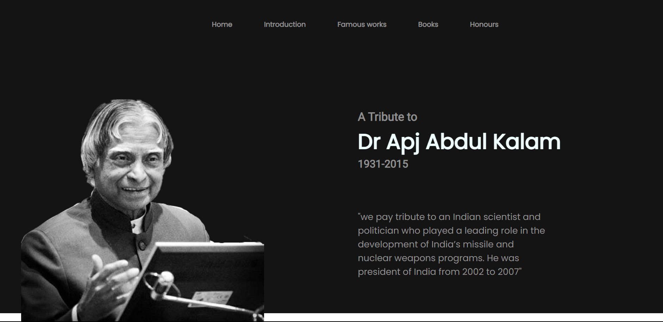

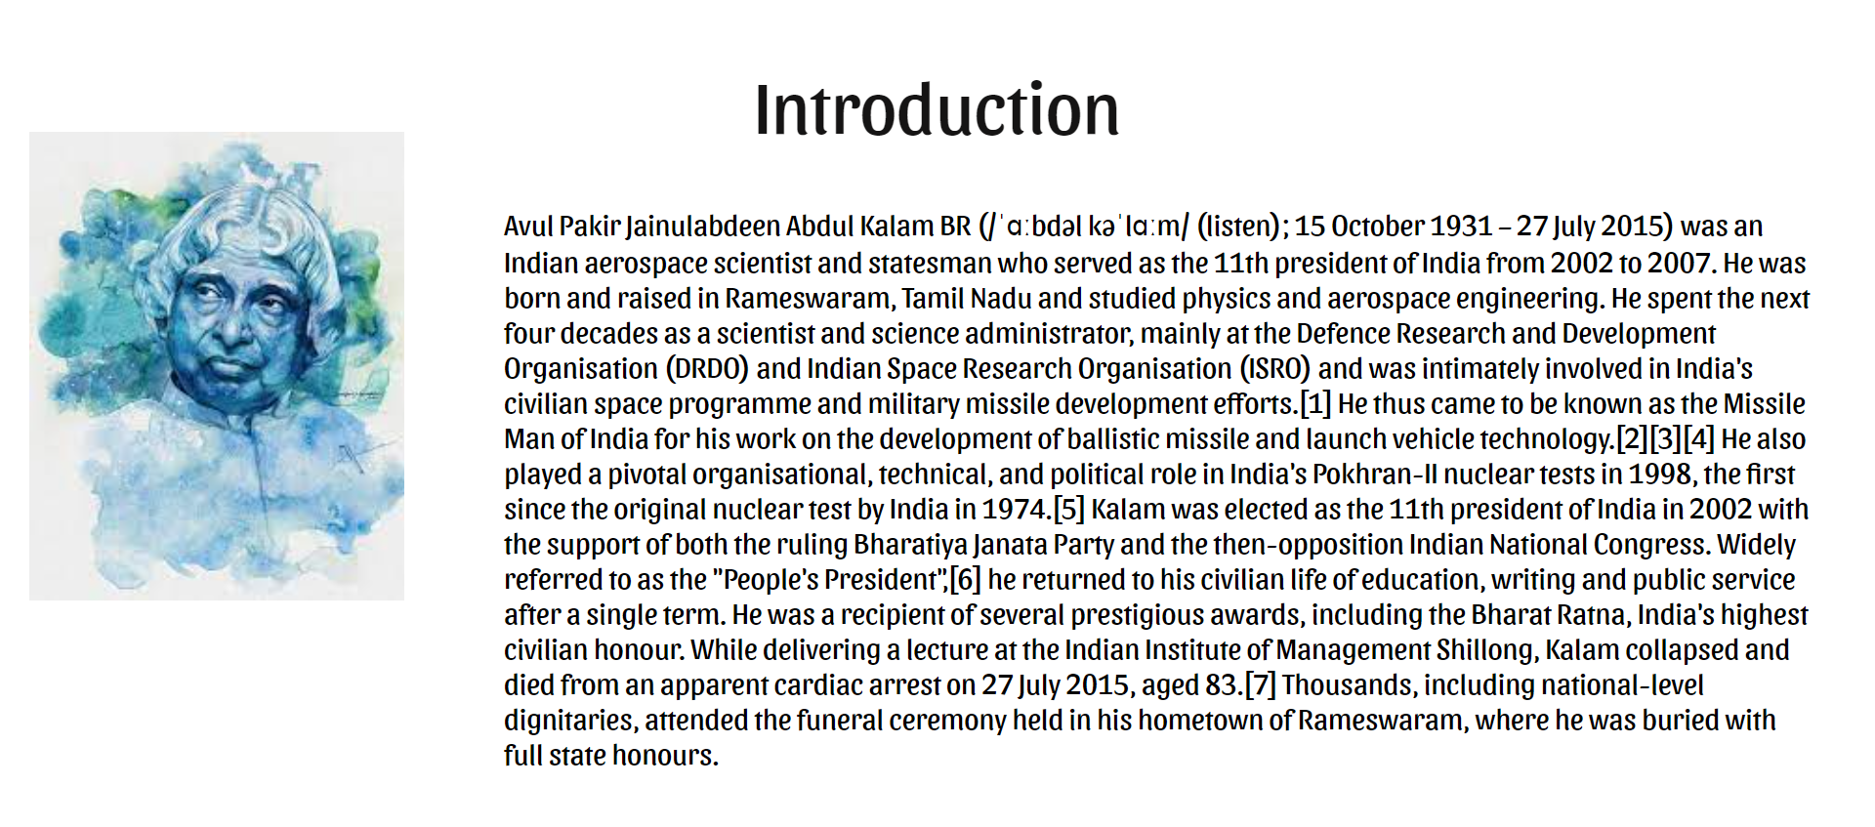

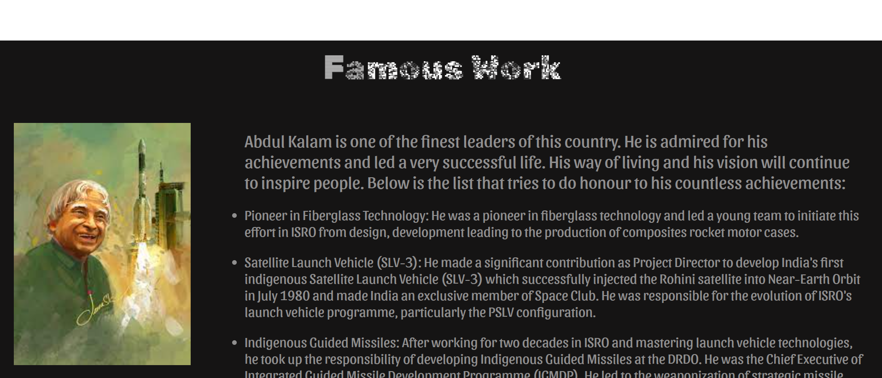

page 6

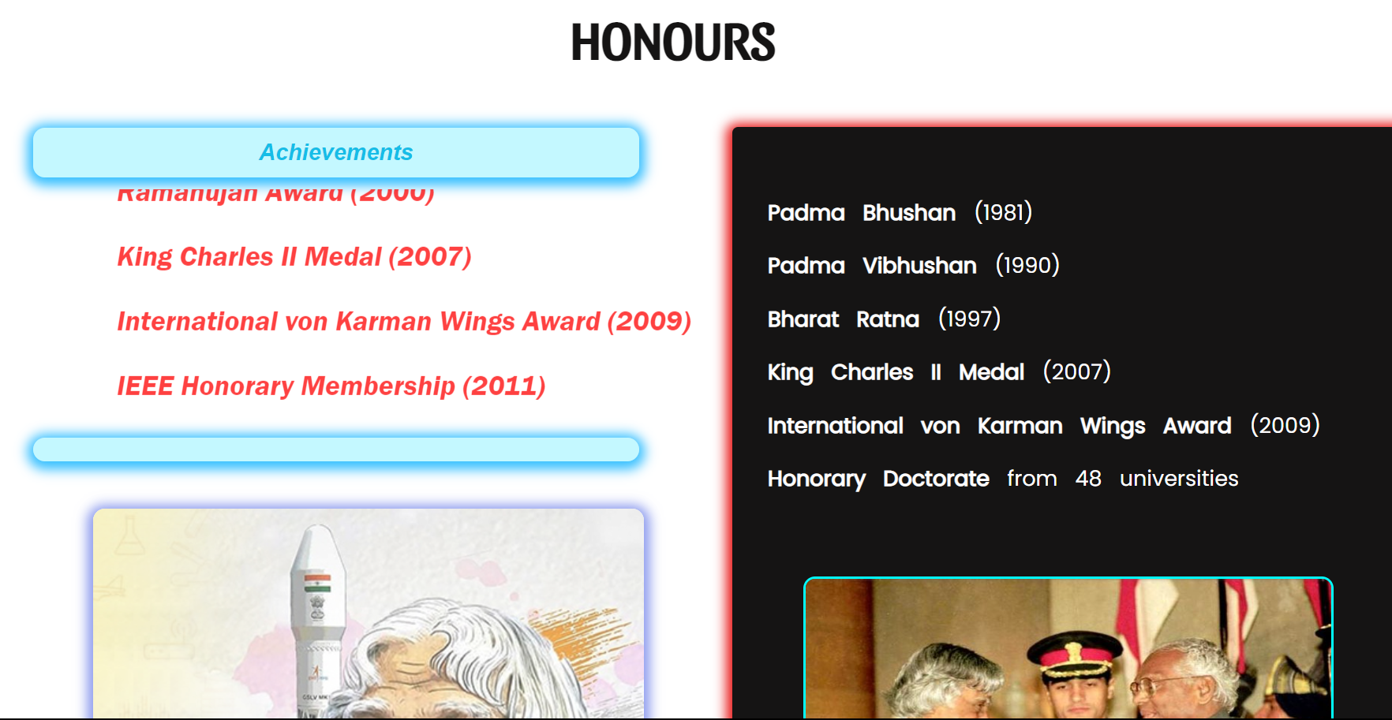

page 7 |

**Conclusion**

In conclusion, the Tribute Page project provides an opportunity to honor and celebrate the life and achievements of a person who has made a significant impact in their field or community. By building a well-designed and engaging tribute page, we can create a lasting and memorable tribute that inspires and educates others.

Throughout the project, we can utilize a range of web development tools and techniques to create a tribute page that is visually appealing, interactive, and informative.

The Tribute Page project is a chance to display our web development skills and creativity while paying tribute to a deserving individual. It can be a rewarding and meaningful project that provides an opportunity to gain experience and new skills, highlighting our work, and create something that has a positive impact on others.

page 8 |